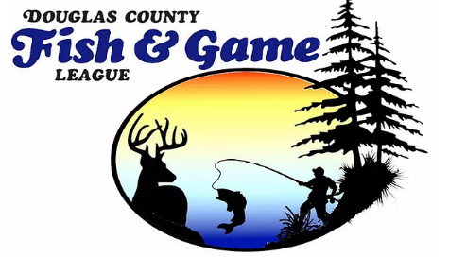

2023 Scholarship Application

The application deadline is Friday, April14, 2023.
Notice of award will be given by June 1st, 2023.
1. Applicants for two $1,000 scholarships must be a Douglas County High School Senior enrolled at Maranatha, Northwestern, Northwood, Solon Springs, or Superior High Schools, who are in good standing, with a GPA of 2.5 or better. Applicants must be applying to, or accepted by, an accredited College/University to pursue a career in Conservation, Law Enforcement, Forestry, Field Biology, Environmental Science, Natural Sciences, Taxidermy, Wildlife Management, or related field as related to hunting, fishing and or trapping.
2. Submit three (3) signed letters of recommendation with contact information from a non-relative who is familiar your goals and aptitude.
3. Write a 300-600 word, typed essay addressing at least one of the following choices:

· Relate a personal experience or program(s) you may have experienced that has helped you to pursue the field of environmental/biological studies as related to hunting, fishing and or trapping.

· Define your motivation for choosing to enter the field of environmental/biological studies and what you would like to accomplish as related to hunting, fishing and or trapping.

· How you have gained the skill and knowledge that will help you to be successful while working in environmental/biological fields as related to hunting, fishing and or trapping.

4. Provide your contact information including your First and Last Name, Mailing Address, email and preferred phone. Also include your High School Name, Address, email and contact phone number.

5. Provide your cumulative High School GPA transcripts or verification from your school's registrar or counselor.
6. Applications must be postmarked two days before or hand delivered to a DCF&GL Director on the deadline by 4:00 p.m. CST.

Send to:
DCF&GL 2023 Scholarship, c/o Bill Reynolds, P.O. Box 131, Gordon, WI 54838

